Question I [9 pts]
Consider the transmission of digital video with a spatial resolution 720x576 at 25 fps. Suppose that the subsampling schema used is the 4:2:0.

- Compute the average bits per pixel. (1 pts)
- What is the new average bits per pixel if the above video is compressed by a factor of 4 ? (3 pts)
- Suppose having a 10Mbit/s transmission channel, how many seconds you need to send 6 minutes of video? (2 pts)
- Suppose that the resolution of the luminance channel is different than the chrominance channels. Given that the resolution is 720x576 for luminance channel and 360x576 for chrominance channels and using the 4:2:0 subsampling schema, what is the size of 6 minutes of video? (3 pts)
Question II [9 pts]
Given the following probabilities of symbols in a message, answer the following:
- Compute the Huffman codes for each symbol? (3 pts)
- What is the efficiency of your codes? (3 pts)
- If the message is composed of 300 symbols, what is the compression factor of your coding if in the original message each symbol is coded on 8 bits? (3 pts)

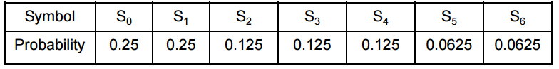
Question III [8 pts]
- Suppose we have the sequence bbaa that we want to code using the arithmetic coding algorithm in which p(a)=0.5 and p(b)=0.5. What is the least sequence of bits that represents bbaa ? (4 pts)

- Decode the following message 96 96 256 256 228 97 259 using LZW. To remind you, the ASCII code of the letter a is 96 and the letter b is 97. (4 pts)
Question IV [4 pts]
Given the following sequence of values, use the DPCM to code the sequence in which the difference is coded on 4 bits only.
123 120 117 132 130 100 105 110 112 107

